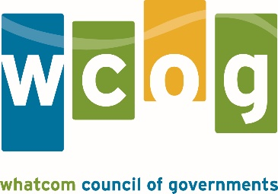

MEMORANDUM

To: Whatcom Transportation Policy Board
From: Lethal Coe, Senior Planner
Date: February 28, 2017
Subject: WCOG 2017 TIP Amendments and Administrative Modifications

Amendment #2 (1703) of the 2017 WCOG Transportation Improvement Program (TIP) includes the following changes:

- Add new WSDOT project: I-5/Tributary to California Creek – Fish Passage. This project will remove existing fish passage barrier and replace with passable structure. The $4 million project is funded primarily through National Highway Performance Program (NHPP). Only Preliminary Engineering and Right-of-way phases are included, the Construction phase will be programmed after 2020.

Formal TIP Amendments require review and resolution from the Policy Board to amend the current TIP and make federal funding accessible.

ACTION REQUESTED: Approve Amendment 1703 for the Whatcom Council of Governments 2017 Transportation Improvement Program.

Whatcom Council of Governments
2017 Transportation Improvement Program

Amendment 1703 Table

# | Agency | Project Title | Amended Action | Added Funds $ | Total Costs $ | Fed Source
1 | WSDOT | I-5/Tributary to California Creek – Fish Passage | Add PE and RW phase | 748,141 | 4,026,040 | NHPP

Administrative Modifications are less substantial project changes than amendments and are administered by WCOG staff.

Administrative Modification 1703

Agency | Project | Modification Administered | Total Costs | Federal Source
Bellingham | West Horton Rd, Phase 1 | Pending Policy Board Action: replace STP funds with local funds up to 1.75 million. | 5,412,000 | STP (US)
Bellingham | Mahogany Ave Arterial | Pending Policy Board Action: replace local funds with STP funds up to 1.75 million. | 7,388,121 | STP (US)
Whatcom | West Horton Rd Extension, Phase 2 | Pending Policy Board Action: change lead agency to Bellingham | 15,000,000 | STP (US)

