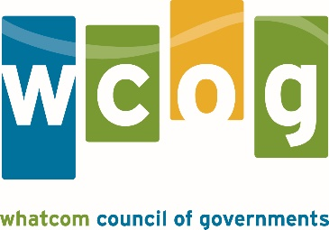

MEMORANDUM

To: Whatcom Transportation Policy Board
From: Lethal Coe, Senior Planner
Date: October 2, 2017
Subject: WCOG 2017 TIP Amendments and Administrative Modifications

Amendment #6 (1710) of the 2017 WCOG Transportation Improvement Program (TIP) includes the following changes:

- Amend WSDOT’s project SR 542/I-5 to Hannegan Road Vicinity – ADA Compliance to increase Preliminary Engineering and Construction phases to bring the total estimated cost of project to $879,671 (prior cost totaled $532,155).
- Add new WSDOT project I-5/Squalicum Creek to SR 539 – Bridge Deck Overlays. The project will rehabilitate select bridges on I-5 and is funded through federal National Highway Performance Program funds. The project will begin preliminary engineering in 2017 and construction in 2019. Total estimated costs = $868,776.
- Add new WSDOT project I-5/Northwest Ave Interchange – ADA Compliance. The project will evaluate and improve pedestrian safety for I-5 and Northwest interchange and is funded through federal National Highway Performance Program funds. The project will begin preliminary engineering in 2017 and construction in 2019. Total estimated costs = $62,769.
- Remove Bellingham project West Horton Road, Phase 1 construction phase. The project will be programmed in the regional TIP and STIP at a later time.

Formal TIP Amendments require review and resolution from the Policy Board to amend the current TIP and make federal funding accessible.

ACTION REQUESTED: Approve Amendment #4 for the Whatcom Council of Governments 2017 Transportation Improvement Program.

Whatcom Council of Governments
2017 Transportation Improvement Program

Amendment #6 (1710) Table

# | Agency | Project Title | Amended Action | Added Funds $ | Total Costs $ | Fed Source
1 | WSDOT | SR 542/I-5 to Hannegan Road Vicinity – ADA Compliance | Increase funding for Preliminary Engineering and Construction | 347,516 | 879,671 | STP
2 | WSDOT | I-5/Squalicum Creek to SR 539 – Bridge Deck Overlays | Add new project | 868,776 | 868,776 | NHPP
3 | WSDOT | I-5/Northwest Ave Interchange – ADA Compliance | Add new project | 62,769 | 62,769 | NHPP
4 | Bellingham | West Horton Road, Phase 1 | Remove project | -4,333,000 | -4,333,000 | STP (US)

Recent Non-Amendment TIP Activities
Administrative Modifications are less substantial project changes than amendments and are administered by WCOG staff.

Administrative Modifications - none

Agency | Project | Modification Administered | Total Costs | Federal Source

